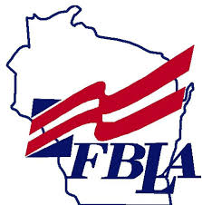
RLC Competitive Event Sign-Up Form

Student Name _____________________________

Grade ____

Written Event – Label your preferred events in order with a 1, 2 & 3

__Business Concepts

__Career Exploration

__Financial Fitness

__Internet Safety

__Intro. to Computers

__Intro. to Business Math

__Intro to FBLA Principles & Procedures

__Proofreading & Editing

Performance/Skill Events – Label your preferred events in order with a 1, 2 & 3

__Computer Slide Show Presentation - Performance (TEAM of 2or3)
Preferred team members: ________________________________________

__Desktop Publishing - Skill/Written (TEAM of 2)
Preferred team members:________________________________________

__FBLA Creed Speaking - Performance (TEAM of 2or3)
Preferred team members:________________________________________

__Intro. to Public Speaking - Performance (Individual)

__Issues in Society - Performance (TEAM of 2or3)
RLC is on Saturday, February 14! Make sure you can attend before you sign up!!!
Preferred team members:________________________________________

__Keyboarding I - Skill/Written (Individual)

__Keyboarding II – Skill/Written (Individual)

__PowerPoint/Slideshow Creation – Skill/Written (Individual)

__Spreadsheet – Skill/Written (Individual)

__Web Site Creation – Performance (Individual or Team (2or3))
Preferred team members: ________________________________________

IMPORTANT!! RLC Competitive Event registration is LIMITED in numbers & is on a First-Come-First-Served basis. Get your forms in to Mr. Nitz or Mrs. Voigt as soon as possible if you want a chance to compete!

Parent Signature: _____________________________________________

